**Personal Portfolio Template**

(Group 28)

(Yu Gen Yeap – n9470379)

(https://github.com/gaffnni/IFB299_TuttingTrumpets/tree/master/Yu%20Gen)

**Artefact 1** – Low Fidelity Web Pages

Description

Low fidelity designs of the models for the admin pages, were created using the moqups app. Artefact shared with Tim Jebson, who created models for the student pages.

Contribution

These low fidelity designs will be the basis of what are high fidelity pages will look like serving as a rough guideline when developing the page layout for the website using HTML and CSS.

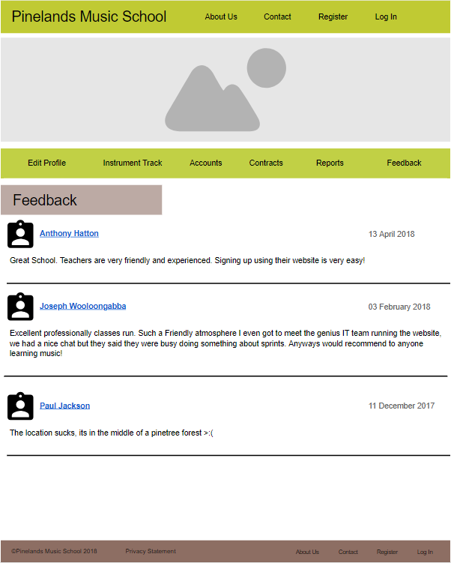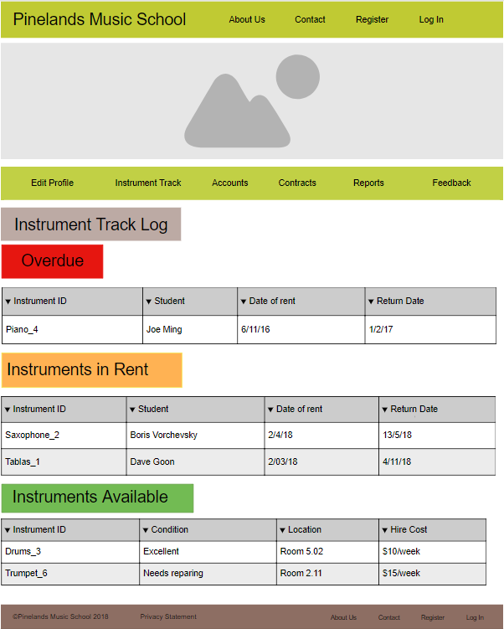Screen captures

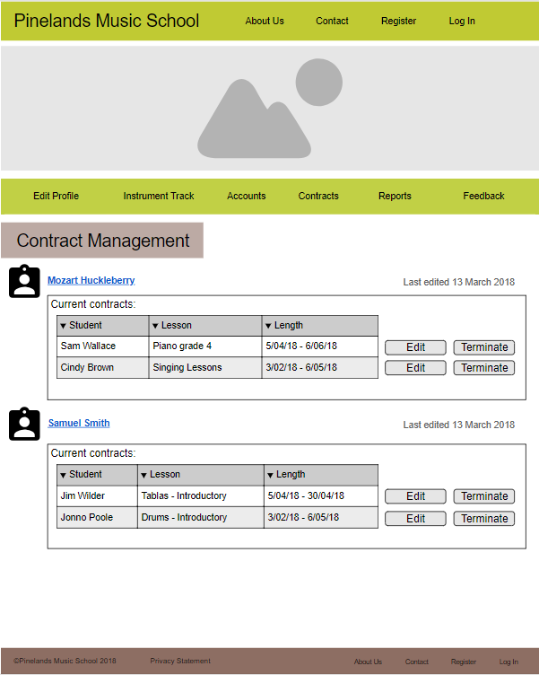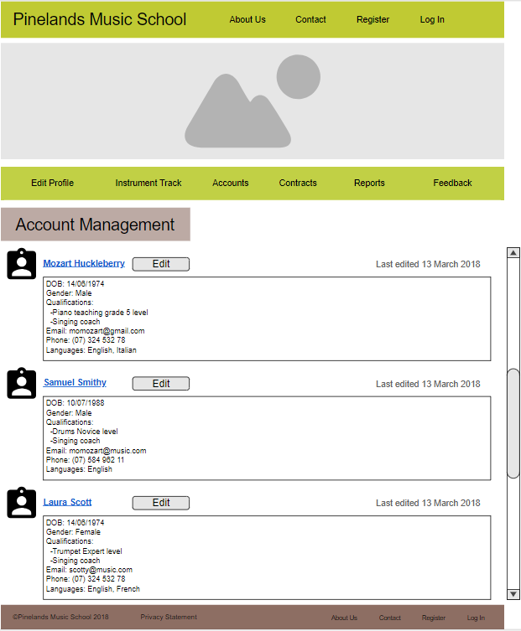

**Artefact 2** – Automated Testing

Description

Automated Unit testing was completed using the Selenium IDE firefox extension to test the functionality of clicking between webpages, registering an account on the webpage and logging in with the account.

Contribution

Automating unit testing allows the team to simulate a user using the website and confirm whether the user stories are satisfied. Unit test’s were also creating using white box testing in order to pick up bugs within the websites functionality. So for the only issue is not being able to input the user’s DOB.

Screen capture  
Note: Only screen captures are available as the Firefox extension version of Selenium does not allow users to save tests suites or test cases as of 4/5/2018

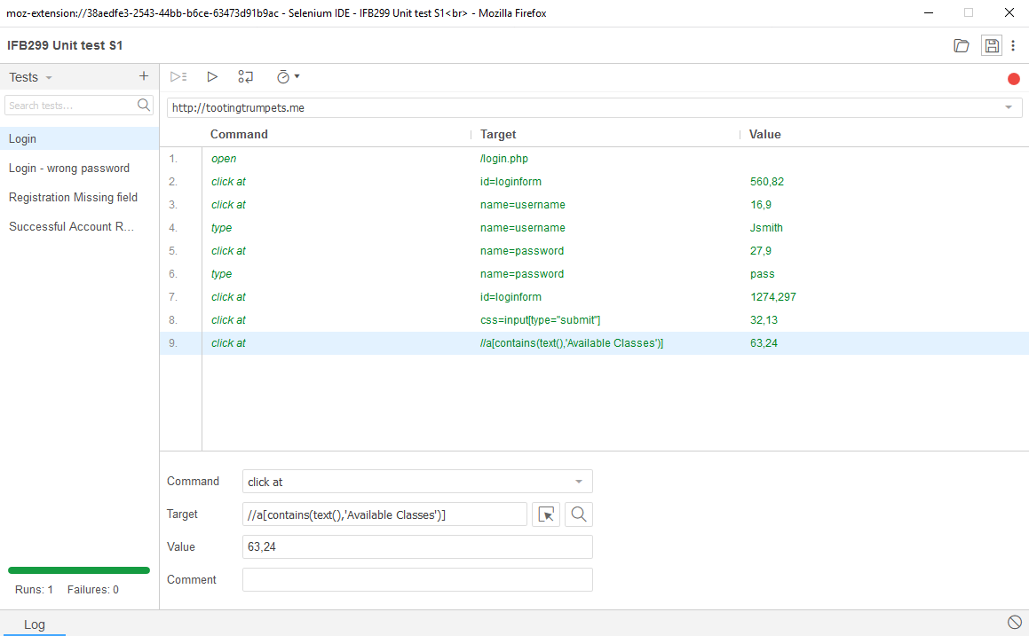

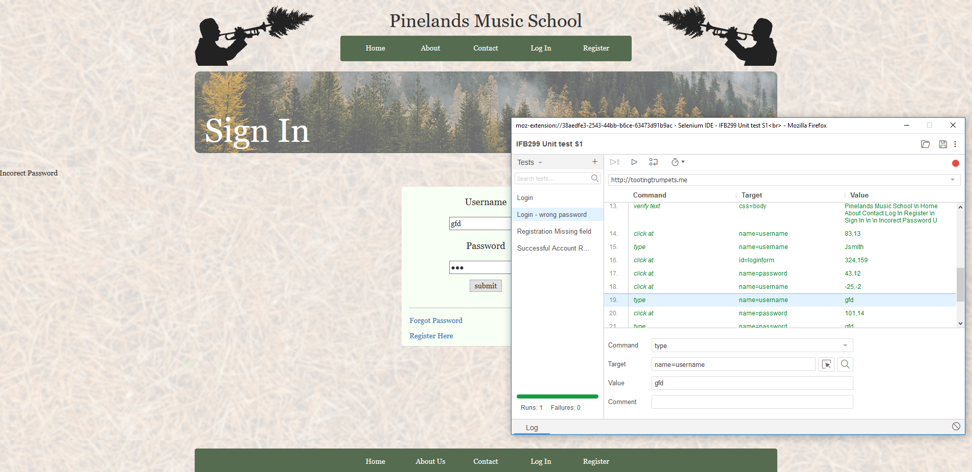

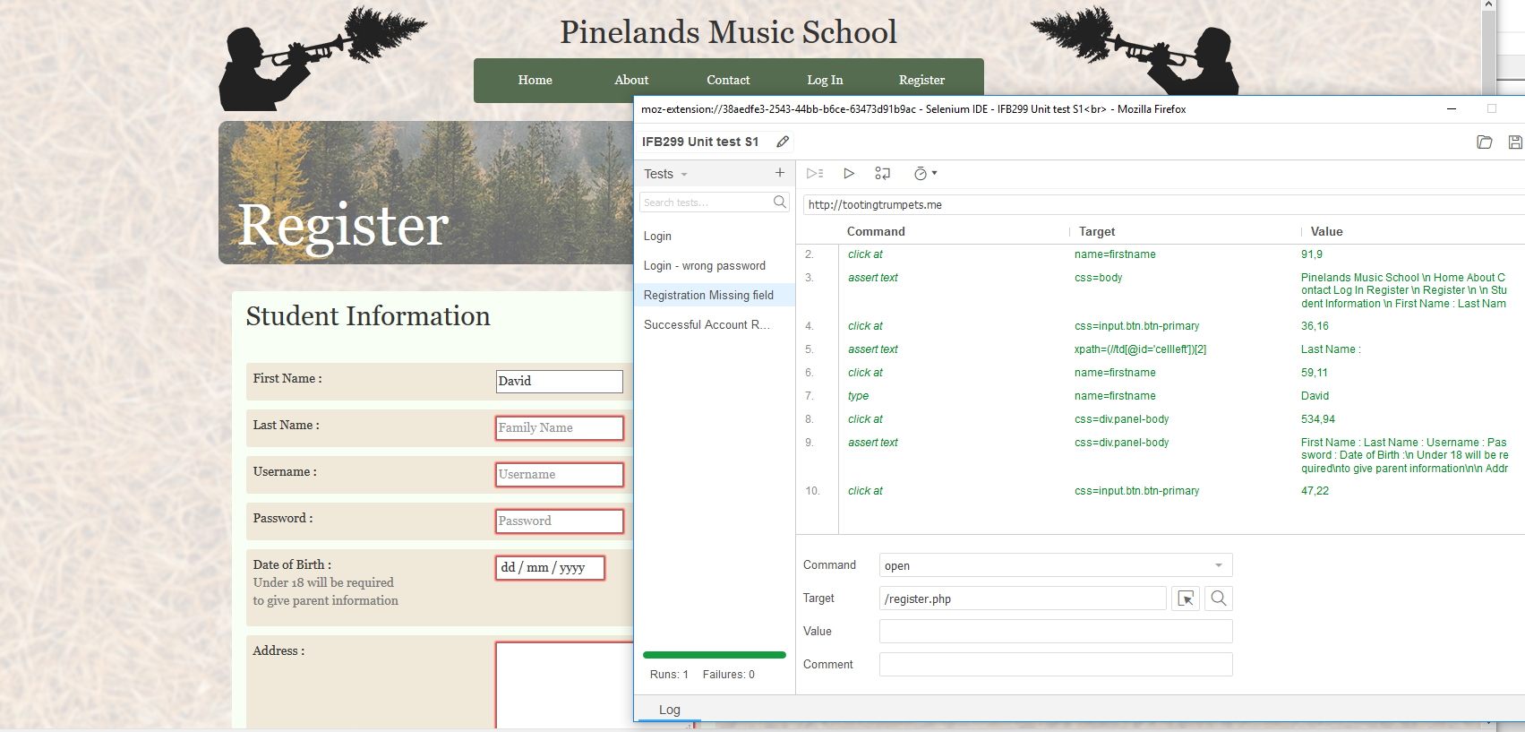

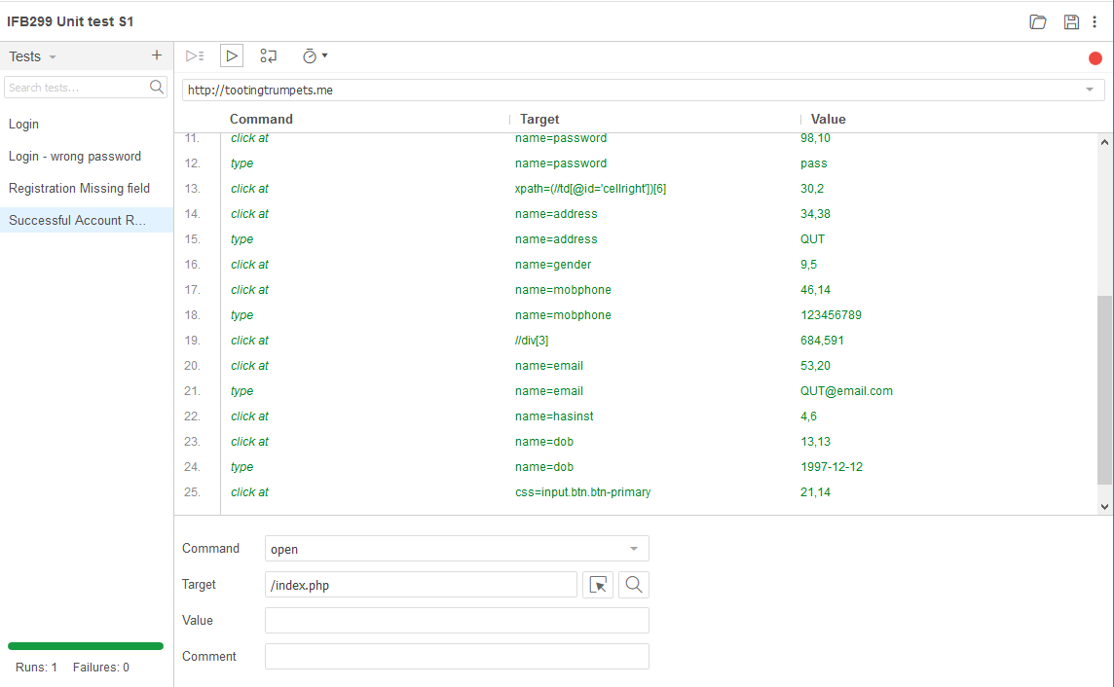

**Artefact 3** – Database Entries

Description

Developed SQL entries for the Admin, Teachers, Students, Languages, skill proficiencies, Instruments, parent details, classes and feedback. Written in SQL. Artefact shared with Nick Gaffney who wrote the other relevant sql files.

Contribution

These are the cases that will fill up the databases which will then be stored on the website.

Screen Capture

